

**News from**

**Ms.Ogorek’s**

**1st Grade Class!**

**August 17th-21st**

### Stay in touch:

Phone: 216-475-8110 Ext.55131

Email: dogorek@ghbulldogs.org

Website: www.msogorek.weebly.com

***Science***

How to think like a scientist

***Social Studies***

PAWS rules

Pillars of character: Trustworthiness, Respect, Responsibility, Fairness, Caring, and Citizenship

***Related Arts*** (Specials) this week:

Monday: Technology

Tuesday: Physical Education (PE)

Wednesday: Music

Thursday: Technology

Friday: Physical Education (PE)

Next Monday: Music

***Reach for Reading***

Kindergarten Review: Letter names and sounds, letter formation, alphabetical order, high frequency words, rhyming, and syllables.

***Classroom Reminders & News!***

* Homework will begin next week
* 1 hour late start on Thursday, August 20th
* Stay organized and bring your Bulldog folder to and from school every day!
* Parents…sign up for Class Dojo and check out our class website at www.msogorek.weebly.com

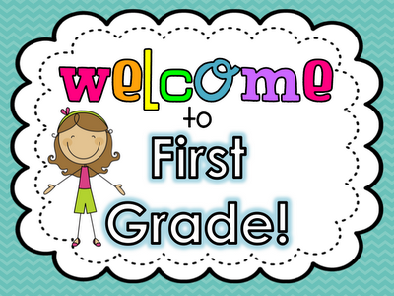

|  |  |  |  |  |  |
| --- | --- | --- | --- | --- | --- |
| ***Homework*** | | | | | |
|  | **Monday** | **Tuesday** | **Wednesday** | **Thursday** | **Friday** |
| **Language Arts** | Homework  starts next week…enjoy! |  |  |  |  |
| **Math** |  |  |  |  |  |

# *My Math*

Review:

Counting, number writing, and establishing calendar routines.

http://www.wallpapersbuzz.com/App/Css/clean.gif