

**News from**

**Ms.Ogorek’s**

**1st Grade Class!**

**August 24th-28th**

### Stay in touch:

Phone: 216-475-8110 Ext.55131

Email: dogorek@ghbulldogs.org

Website: www.msogorek.weebly.com

***Science***

Continue with…

How to think like a scientist

***Social Studies***

Continue with…

PAWS rules and Pillars of character: Trustworthiness, Respect, Responsibility, Fairness, Caring, and Citizenship

***Related Arts*** (Specials) this week:

Monday: Music

Tuesday: Technology

Wednesday: Physical Education

Thursday: Music

Friday: Technology

Next Monday: Physical Education/Library

***Reach for Reading***

Continuing review of: Letter names and sounds, letter formation, alphabetical order, high frequency words, rhyming, and syllables.

Sight word review: on ride I see

a funny like to my can is

this little big that pretty the find and you me too

***Classroom Reminders & News!***

* Turn in homework daily and read every night
* 1 hour late start on Thursday, August 27th
* Stay organized and bring your Bulldog folder to and from school every day!
* Parents…Reading a to z accounts coming home this week. First quarter goal is level D or higher.

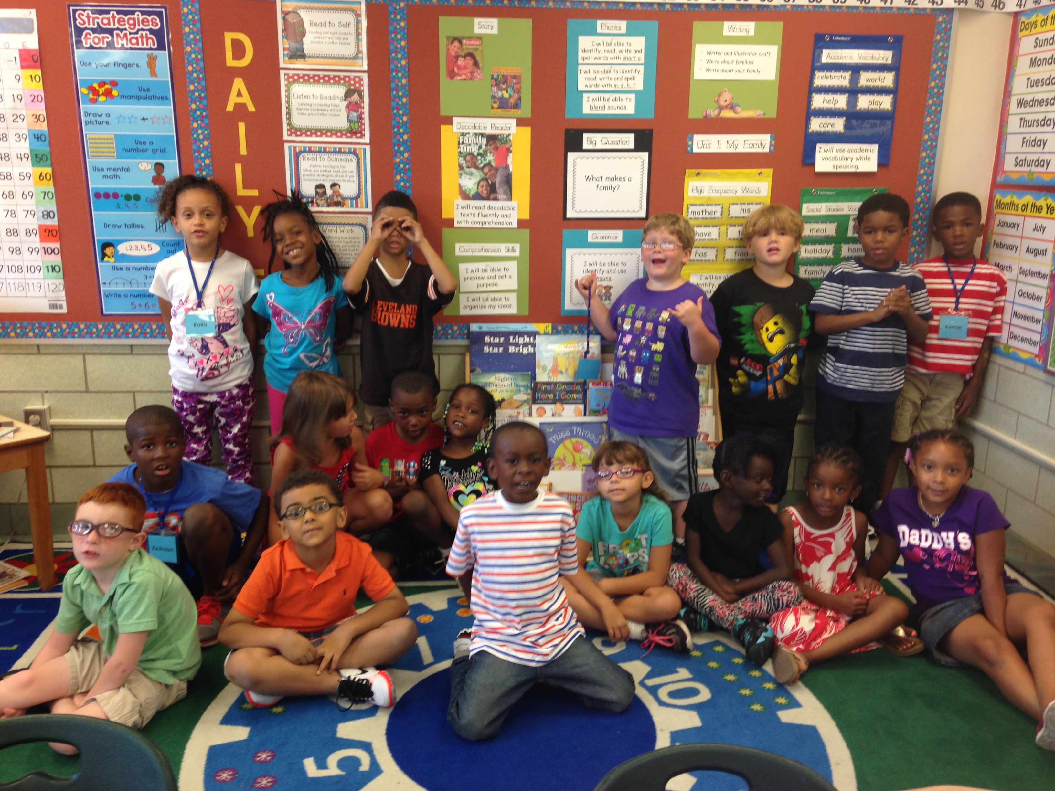



# *My Math*

Reviewing:

Counting to 120, number writing to 30, shapes, positional words, and establishing calendar routines.

|  |  |  |  |  |  |
| --- | --- | --- | --- | --- | --- |
| ***Homework*** | | | | | |
|  | **Monday** | **Tuesday** | **Wednesday** | **Thursday** | **Friday** |
| **Language Arts** | Read 15-20 minutes tonight! | Read 15-20 minutes tonight!  Complete worksheet | Read 15-20 minutes tonight! | Read 15-20 minutes tonight!  Complete worksheet | No homework on Friday, enjoy your family and read together over the weekend!  parents reading |
| **Math** | Counting/  number worksheet | Practice counting to 120 by ones and twos | Counting/  number worksheet | Practice counting to 120 by fives and tens |

http://www.wallpapersbuzz.com/App/Css/clean.gif