

**News from**

**Ms.Ogorek’s**

**1st Grade Class!**

**September 7th-11th**

### Stay in touch:

Phone: 216-475-8110 Ext.55131

Email: dogorek@ghbulldogs.org

Website: www.msogorek.weebly.com

***Science***

Continue with … Pushes and Pulls

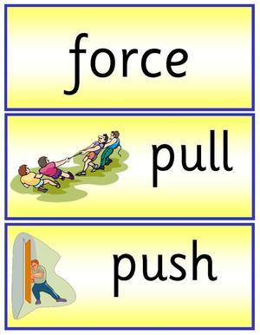

***Social Studies***

Continue with…

Working Hard

Doing our Best

Raise Hand to Speak

***Related Arts*** (Specials) this week:

Monday: No School-Labor Day

Tuesday: Technology

Wednesday: Physical Education

Thursday: Music

Friday: Technology

Next Monday: Physical Education

***Reach for Reading***

Continuing review of: Vowel names and sounds, letter formation, identifying a sentence, high frequency words, rhyming, and syllables.

Sight word review: I, is, little, am, on, a, like, the, and, this, that, her, him

***Classroom Reminders & News!***

* Thank you for attending our Open House last week!
* PTA Meeting at Elmwood on Wednesday at 6:30!
* Be sure your child puts their name on their homework so they get credit for their hard work each night.

(No name, no credit, sorry)

|  |  |  |  |  |  |
| --- | --- | --- | --- | --- | --- |
| ***Homework*** | | | | | |
|  | **Monday** | **Tuesday** | **Wednesday** | **Thursday** | **Friday** |
| **Language Arts** | No school  Labor Day  http://holidays.mrdonn.org/banner_labor_day.GIF | Read 15-20 minutes tonight!  Complete worksheet | Read 15-20 minutes tonight!  Complete worksheet | Read 15-20 minutes tonight!  Complete worksheet | Lucky Listener Poetry binder:  Read poems together and the lucky listener signs the sheet.  (Return on Monday)  http://newsinhealth.nih.gov/images/Speech-and-Language.gif |
| **Math** |  | Worksheet  Lesson 1-4 | Worksheet  Lesson 1-5 | Worksheet  Lesson 1-6 |

**Chapter 1:** How Do You Add Numbers?

**Objectives:** Students will…

Find sums by adding zero.

Write addition facts horizontally and vertically. Write number sentences to solve problems.

**Vocabulary:**

Review – equals, sum, add, plus

New – zero

# *My Math*