

**News from**

**Ms.Ogorek’s**

**1st Grade Class!**

**September 14th-18th**

### Stay in touch:

Phone: 216-475-8110 Ext.55131

Email: dogorek@ghbulldogs.org

Website: www.msogorek.weebly.com

***Related Arts*** (Specials) this week:

Monday: Physical Education/Library

Tuesday: Music

Wednesday: Technology

Thursday: Physical Education

Friday: Music

Next Monday: Technology

***Social Studies***

Continue with following rules…

Showing Respect

Raising Hand to Speak

Quiet in the hallway

***Science***

Continue with … Pushes and Pulls

 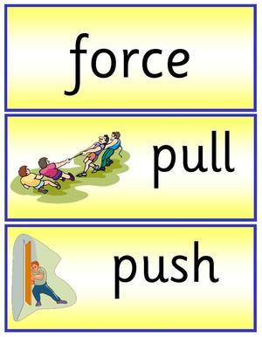

***Reach for Reading***

Unit 1 – Week 1

**Big Question**: What is a Family?

**Comprehension:**

Preview and set a purpose

Organize ideas

**Phonics:**

Identify and write sounds and letters *m, s, h, t*

Read and spell words with short *a*

Read decodable text: *Family Time*

**Grammar:** Nouns (person, place, or thing)

**High frequency words** (read and spell):

find, has, have, his, mother too

**Vocabulary [Key Words]:** (Understand the meaning)

Social studies vocabulary-family, family member, holiday, home, meal

Academic vocabulary-care, celebrate, help, play, world

**Writing:** Writing about families

**Chapter 1:** How Do You Add Numbers?

**Objectives:** Students will…

Use counters to make sums of 4, 5, 6, 7, 8, and 9 in different ways.

**Vocabulary:**

Review – sum, add

New – in all, same

# *My Math*

***Classroom Reminders & News!***

> PTA Meeting at Elmwood on Wednesday at 6:30!

> Return poetry binder each Monday. Also return reading log completed for the prior week.

> Reading is the best way to become a better reader!

> Any questions feel free to contact me!

|  |  |  |  |  |  |
| --- | --- | --- | --- | --- | --- |
| ***Homework*** | | | | | |
|  | **Monday** | **Tuesday** | **Wednesday** | **Thursday** | **Friday** |
| **Language Arts** | Read 15-20 minutes tonight and fill out reading log!  Complete worksheet and practice decodable text: *Family Time* | Read 15-20 minutes tonight and fill out reading log!  Complete worksheet and practice decodable text: *Family Time* | Read 15-20 minutes tonight and fill out reading log!  Complete worksheet and practice decodable text: *Family Time* | Read 15-20 minutes tonight and fill out reading log!  Complete worksheet and practice decodable text: *Family Time* | In class Friday:  Students will be assessed on…  Comprehension  Vocabulary  Grammar & Writing  Foundational skills:  Phonological awareness  Decoding  High frequency words |
| **Math** | Worksheet  Lesson 1-7 | Worksheet  Lesson 1-8 | Worksheet  Lesson 1-9 | Worksheet  Lesson 1-10 | **Return poetry binder and reading log on Monday!** |